Resources: URL 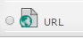
An URL is a link on the Internet to a website or an online file. Instructors may use the URL to provide their students with web links for research, saving the student time and effort in manually typing out the address. One may also use URLs to link to interactive resources and videos.

Contents
- Add an URL
- Edit Settings
- Delete an URL

Add a URL
- Click on the Turn editing on button at the top right of the screen.
- Click Add an activity or resource.
- Click the radio button next to the URL and click on the Add button.
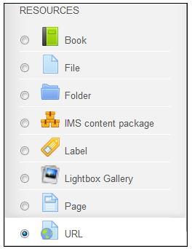
The "Adding a new URL" page will appear.
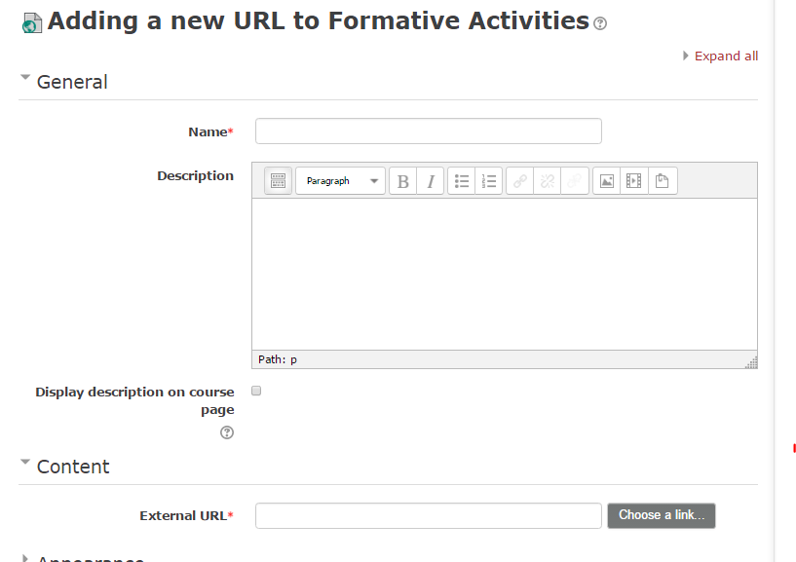
- Type a Name and Description (optional). The Name will be the title given to the activity on the Moodle course page. For easy student navigation, choose a Name that is specific and clear as to what the resource is. The Description is for your reference unless you check the box below the Description: Display description on course page. Only choose this option if it is necessary. This clutters the home page of your course.
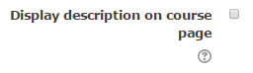
- Type or paste a copied web address in the "External URL" box in the content section.

- Automatic | The best display option for the URL is selected automatically.
- Embed | The URL is displayed within the URL description.
- Open | Only the URL is displayed in the browser window.
- In pop-up | The URL is displayed in a new browser window with menus  and an address bar.
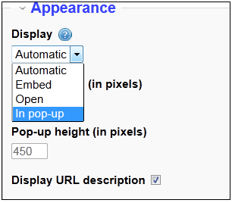
- Select the Display in the Appearance section.

- Click on the Save and return to course button.
Edit Settings
- Go to the course home page.
- Click on the Turn editing on button at the top right of the page.
- Click Edit next to the URL resource.
- Click Edit settings. You may choose to give a more descriptive name for the Internet Resource, add a different link, or give a description.

Delete a URL
- Go to the course home page.
- Click on the Turn editing on button at the top right of the page.
- Click Edit next to the URL resource.
- Click Delete.
Notes:
For additional information, see the Moodle Docs URL Resource or contact Moodle Help.

